# Lab - 6 NCL Wireless Access Exploitation

|  |
| --- |
| * This is an individual assignment, and is worth 20 points. * The due date and time is Friday, October 20 Midnight. * Change the file name following the naming convention suggested below. Naming convention is as follows: homework, underscore, last name, first initial, and extension (e.g., Crypto-Assignment-ImG.docx). If you do not follow the convention, I will deduct 0.5. |

* Log in to the following site: https://ncl.cyberskyline.com
* Go to Dashboard > NCL Fall 2017 Gymnasium > Wireless Access Exploitation
* You will find five questions. Answer each question and provide necessary screenshots and explanation to justify your answer. Take advantage of the hints provided on the page.

1. How many IVs are in the packet capture? Provide a screenshot that supports your answer.

* Hints: For this, go to Kali Linux and launch Firefox. And login to ncl.cyberskyline.com, and download the pcap file on Kali Linux.

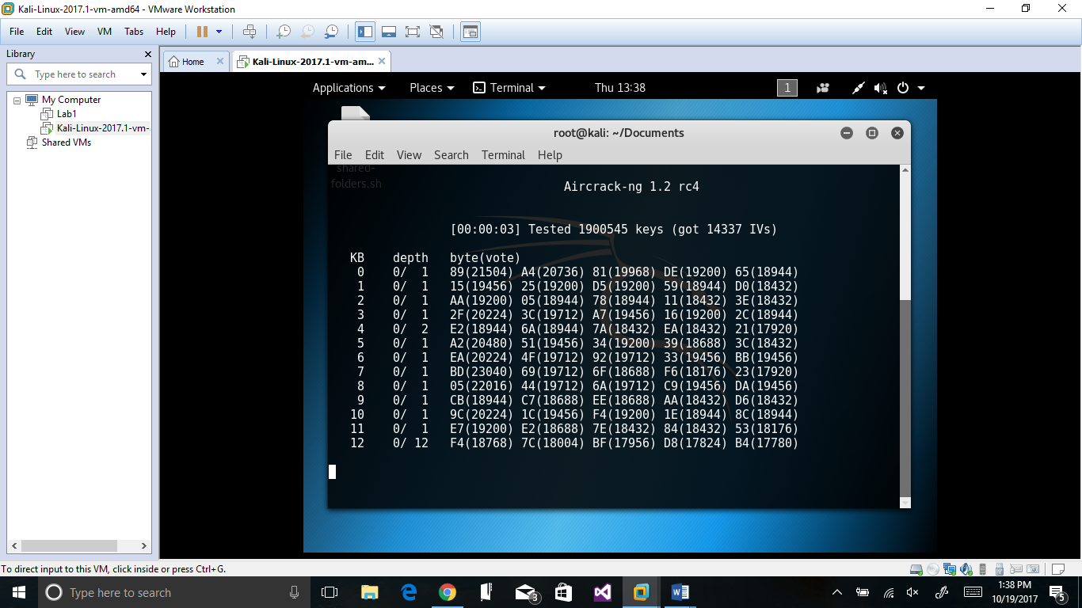

1. What is the key size of the wireless network in bits? Explain how you arrived at your answer.

64 bits. The 5 bytes * 8 bits per byte = 40 bits and there are 24 bits that are added as a factory-set, non user-configurable input in order to generate a 64-bit encryption key.

1. What is the IV for the first packet in the capture (in hex)? Provide a screenshot that supports your answer.

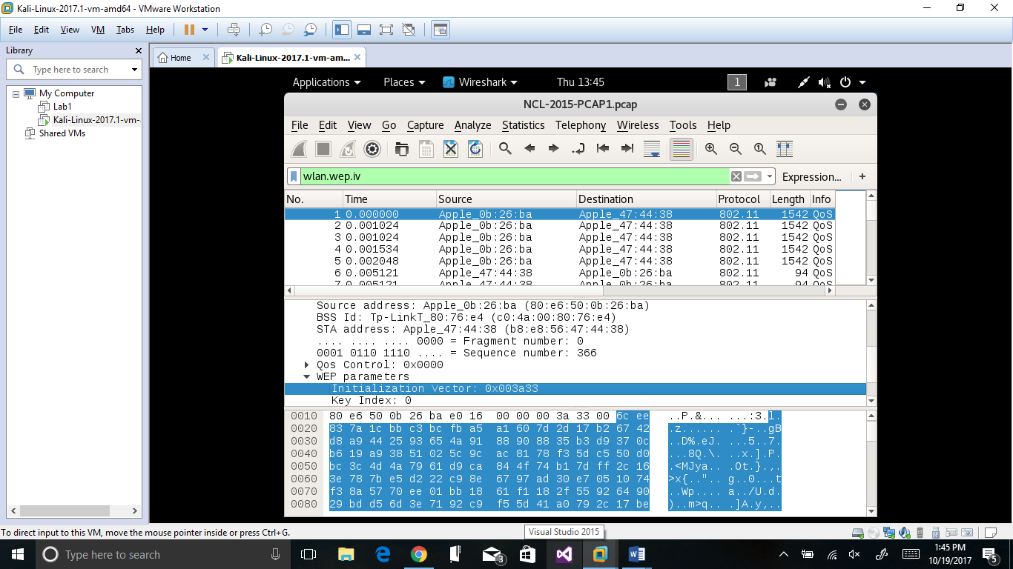

0x003a33

1. What is the WEP key? Provide a screenshot that supports your answer.

A4:81:53:B4:CF

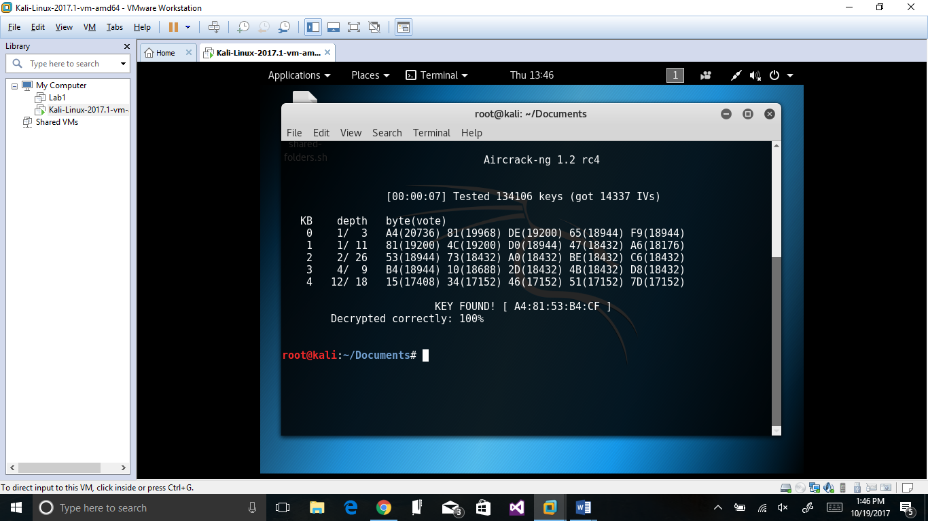

1. What is the TCP checksum of the first packet in the capture (in hex)? Provide a screenshot that supports your answer.

0x897b

